

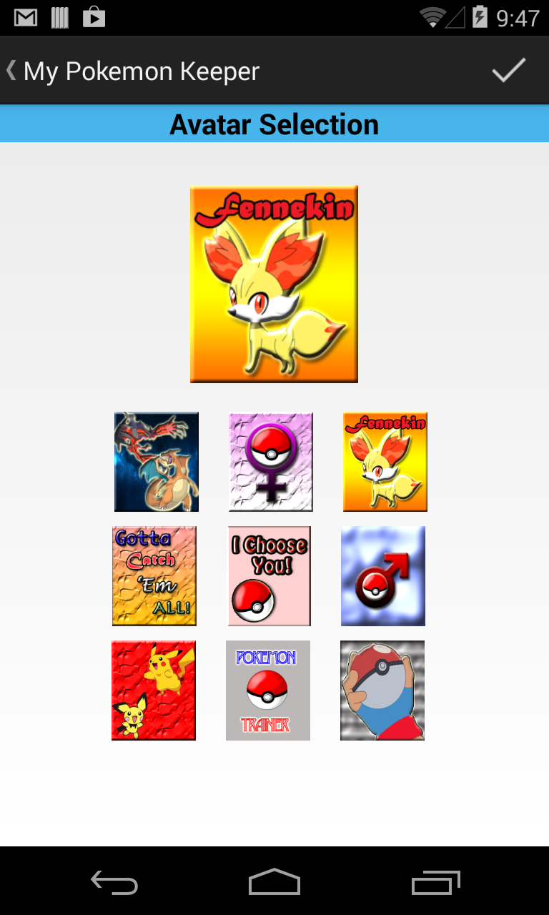

2

2

Visual Progression (if applicable)

Progression Summary

Fill out one form per feature (not activity). In the Visual Progress pane, try and outline any progress you will have made to features that affect the visual display of the app - UI Views, Navigation Controls, etc. Don’t show the entire screen (unless applicable), concentrate on the feature.

Expected Functionality



The user will be able to select from nine custom made avatars to make as their Profile Card photo. The user will also be able to see a larger image of the selected avatar before adding it to the Profile Card.

Details & Status

AvatarPage

ImageViews

0

Activity

Feature

Est. Hours

Completed

0

Actual

12/03/2013

Hours

Hours

Hours

Hours

Component

Component

Component

Component

Components

Changes & Outcomes



Photoshop was used to create the custom avatars. The main issue that I ran in to was making sure the images were not blurry when they were displayed in the larger image view.

Custom made avatars

2



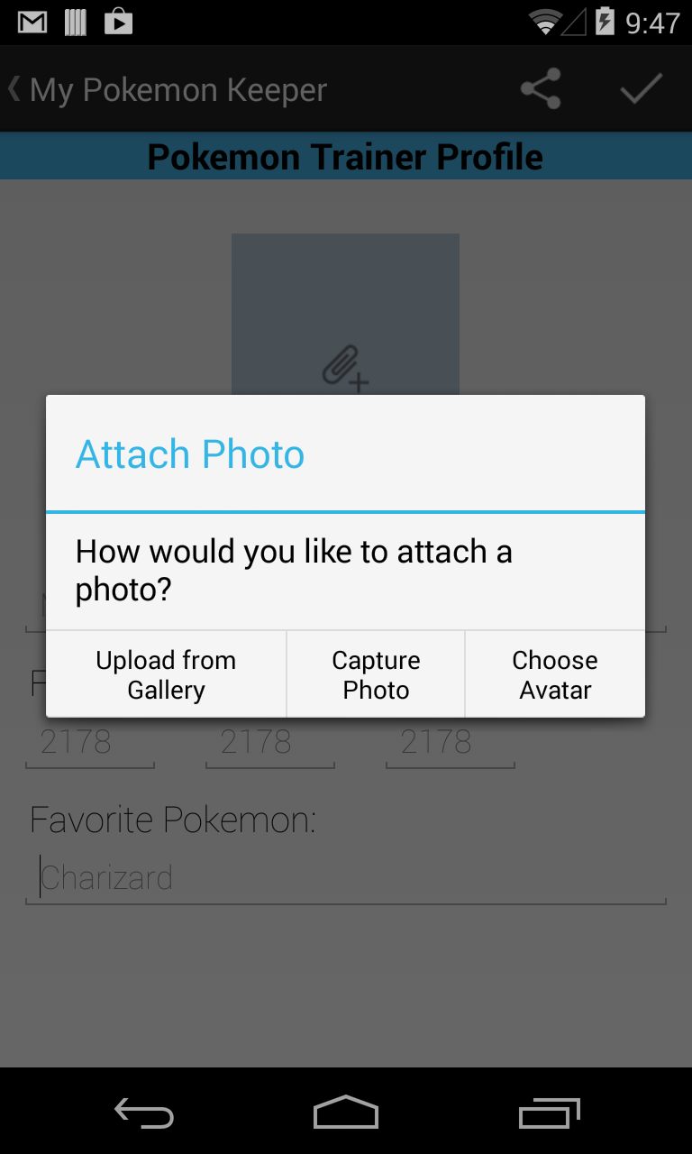

9

4

2

Capture Photo Function

Progression Summary



Visual Progression (if applicable)

Fill out one form per feature (not activity). In the Visual Progress pane, try and outline any progress you will have made to features that affect the visual display of the app - UI Views, Navigation Controls, etc. Don’t show the entire screen (unless applicable), concentrate on the feature.

Expected Functionality



The user will be able to attach a photo from the gallery or take a new photo. The user will also have an option to select an avatar.

Details & Status

ProfileCard

Image View

0

Activity

Feature

Est. Hours

Completed

0

Actual

12/05/2013

Hours

Hours

Hours

Hours

Component

Component

Component

Component

Components

Changes & Outcomes



The big challenge was getting the avatars to display on the “ProfilePage”. The other challenge was making sure that the image the user selects stays displayed even when the user exits the application.

Attach Photo Function

2



1

1



Progression Summary



Visual Progression (if applicable)

Fill out one form per feature (not activity). In the Visual Progress pane, try and outline any progress you will have made to features that affect the visual display of the app - UI Views, Navigation Controls, etc. Don’t show the entire screen (unless applicable), concentrate on the feature.

Expected Functionality



The user will be able to view the “About” page by tapping the info icon. By tapping the plus icon, the user can navigate to the “Add New” page. The smiling icon will navigate the user to the “Profile Card” page.

Note: The “Captured Pokemon” and “Add New” pages will be created at a later milestone.

Details & Status

MainPage

Action Bar

0

Activity

Feature

Est. Hours

Completed

0

Actual

12/02/2013

Hours

Hours

Hours

Hours

Component

Component

Component

Component

Components

Changes & Outcomes



The ActionBar makes navigation easier for the using.

ActionBar

1